# 

**Deep Learning Food Classification Project**



Contents

1. Overview 3

2. Data Preprocessing and Data Loading 4

3. Develop the Image Classification Models 5

4. Evaluate models using Test Images 16

5. Use the Best Model to perform classification 18

6. Summary 25

# Overview

The objective of this project is to build an image classification model to recognize and classify 10 different types of food. The dataset for this project is a collection of 101,000 images of food, organized by the type of food, which can be downloaded from Kaggle. Each student is assigned 10 types of food to perform image classification on, and a Jupyter notebook is provided to extract the images for these specific types of food and split them into training, validation, and testing sets. The goal is to develop at least two different models for this classification task, one trained from scratch using conv2D and dense layers, and another utilizing pre-trained models. The suggested approach is to follow the universal machine learning workflow to develop and improve the model performance, including analyzing and tuning the model's hyperparameters. The models will be evaluated using the test images, and the best model will be recommended based on performance. The best model will then be used to classify additional food images downloaded from the internet.

# Data Preprocessing and Data Loading

After downloading the food images dataset from Kaggle, all 101,000 images of 101 food types are extracted into a local folder. Alongside the provided Image_Preprocessing jupyter notebook and a 20.txt file, containing 10 food types assigned to me, I begin to extract the images that I will be using for training, validating and testing the food image classification model.

Inside the Image_Preprocessing notebook, the base_dir variable is set to the current working director, and the image_dir is set to the local directory containing all the extracted images from the dataset. It then creates three additional directories in the base_dir named train, validation, and test. It then reads the 10 food types inside 20.txt and stores them as a list in the food_list variable.

The code then iterates over each of the items in food_list, creating a new directory, train_dir, with the name of the current item and gets a list of the first 7500 image filenames from the image_dir. It then iterates over the filenames in the list and copies each file from the image_dir to the new train_dir file, to be used as the training data.

This is repeated for the validation_dir, using the next 2000 images, and the test_dir, using the remaining 500 images, acting as the validation and testing data respectively.

Moving on, the data is loaded into the classification model notebook using the same base_dir which also creates the train_dir, validation_dir, and test_dir by appending the string of their respective data functions.

Some additional notes, a NVIDIA GeForce GTX 1060 6GB gpu and Intel Core i3-8100 CPU @ 3.60GHz was used to run all machine learning models. Inside the jupyter notebook, the model history of the last 10 epochs of each model is shown as the models were run in a different file before being compiled in the assignment file. The same reasoning applies to the graphs.

# Develop the Image Classification Models

To build and train the models for this assignment, I began by establishing a baseline model and increasing its complexity. I also analyzed the model's performance during the training phase to identify any trends or patterns that might point to areas for improvement. This included tracking key metrics such as the model's accuracy, loss, and convergence rate, as well as visualizing the performance through graphs and plots. By regularly monitoring the model's performance, I was able to identify any issues and make adjustments to the model or training process as needed to enhance its performance.

**Table of every recorded model that was built**

| Model | Test/Tune/Changes | Train Accuracy | Validation Accuracy | Test Accuracy |
| --- | --- | --- | --- | --- |
| 1 | Baseline Model | 99.72% | 36.10% | 34.99% |
| 2 | Added more complex layers, Sigmoid activation, Adjusted learning rate, Higher Epoch | 71.59% | 66.2% | 67.4% |
| 3 | Extremely complex layers, Softmax activation | 61.64% | 55.35% | 55.4% |
| 4 | Different layers, Using SGD optimizer | 55.39% | 52.85% | 53.2% |
| 5 | Same as model 2, Sigmoid activation, different batch size | 72.88% | 67.40% | 66.6% |
| 6 | Same as model 5, Softmax activation, different batch size | 68.44% | 67.95% | 67.80% |
| 7 | Same as model 6, different batch size | 67.07% | 65.40% | 63.4% |
| 8 | Same as model 7, 200 epoch | 70.29% | 65.56 | 67.20% |
| 9 | Same as model 7, added dropout, different batch size | 66.53% | 66.95% | 66% |
| 10 | Same as model 9, added dropout and conv2d layers | 68.11% | 65.45% | 66.40% |
| 11 | Same as model 7, different learning rate | 73.04% | 65.45% | 64.00% |
| 12 | Different layers, SGD optimizer | 80.51% | 72.60% | 72.80% |
| 13 | Same as model 12, AdaGrad optimizer | 90.32% | 70.90% | 72.2% |
| 14 | Pretrained Model, VGG16, sigmoid activation, RMSprop optimizer | 85.19% | 79.35% | 78.00% |
| 15 | ResNet50, sigmoid activation | 86.32% | 78.65% | 77.80% |
| 16 | VGG19, softmax activation, SGD optimizer | 69.08% | 73.75% | 74.60% |
| 17 | InceptionV3, softmax activation, 512 dense layer, AdaGrad optimizer | 88.05% | 81.30% | 78.80% |
| 18 | Same as model 17, freeze all blocks | 67.57% | 70.10% | 70.40% |
| 19 | Same as model 17, freeze up to block 7, 25 epoch | 72.33% | 70.85% | 70.00% |
| 20 | Same as model 17, 25 epoch | 95.33% | 83.60% | 84.2% |
| 21 | Same as model 19, 50 epoch | 100% | 67.75% | 66.80% |

To fine-tune the model's hyperparameters, I tried out a range of different values for each parameter and assessed the effect on the model's performance. By carefully adjusting the hyperparameters, I was able to enhance the model's accuracy in classifying the images and decrease overfitting.

Starting with the first model, the baseline, I added simple layers, a softmax activation with 10 classification types, categorical cross-entropy, RMSprop optimizer function with a learning rate of 0.001 without any data augmentation. I used a batch size of 50 for both the training data and validation data. As both data samples contain 7500 and 2000 images respectively, the steps per epoch is 150 and validation steps is 40.

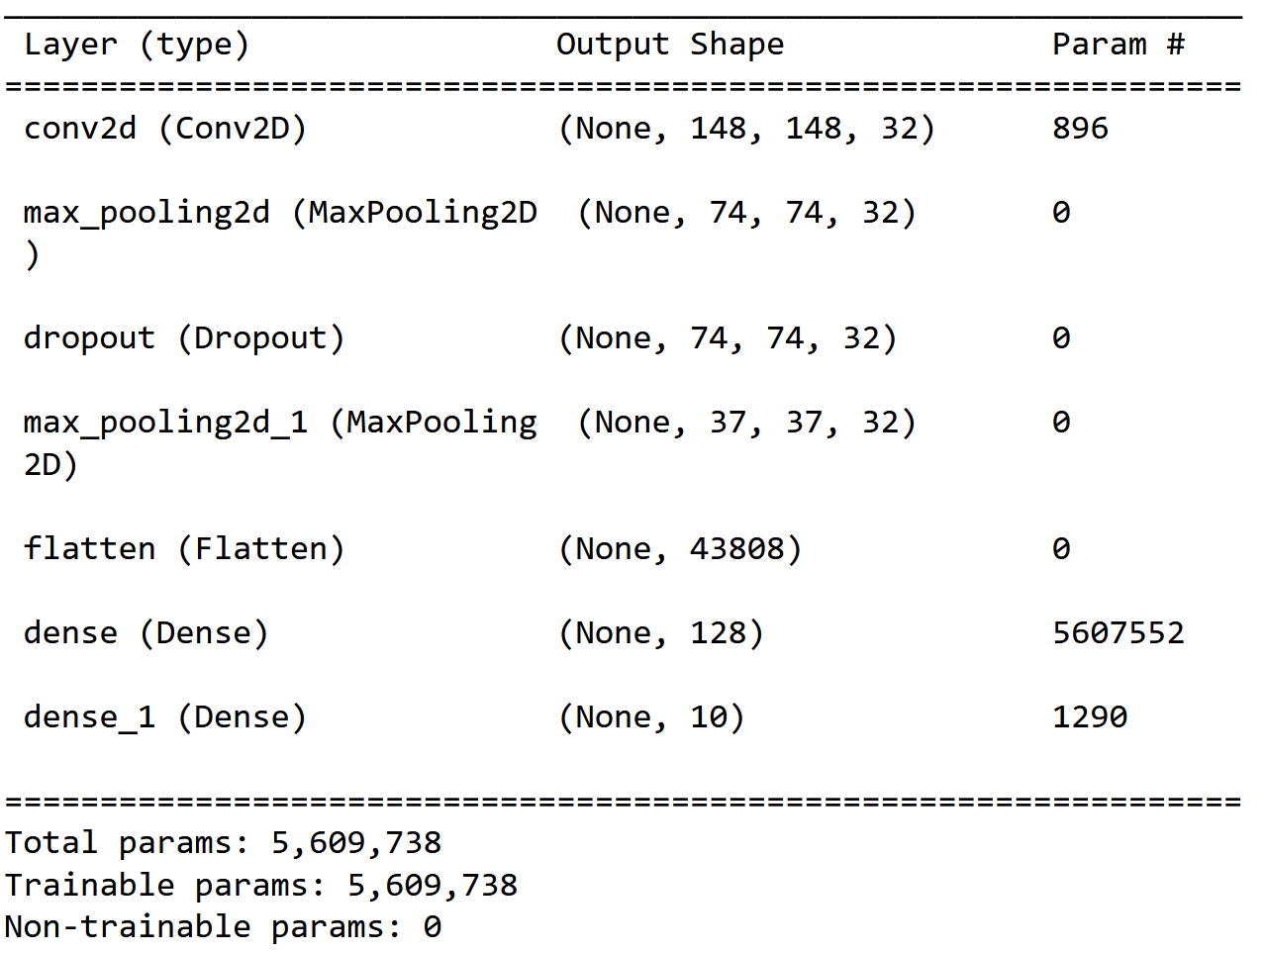

After 50 epochs, the model was able to achieve a high training accuracy of 99.72% but a low validation accuracy of 36.10% and test accuracy of 34.99% acting as a good baseline for the remaining models. The accuracy and loss chart can be seen below, showing that the model peaked in its validation accuracy around its 4th epoch and began overfitting from then on.

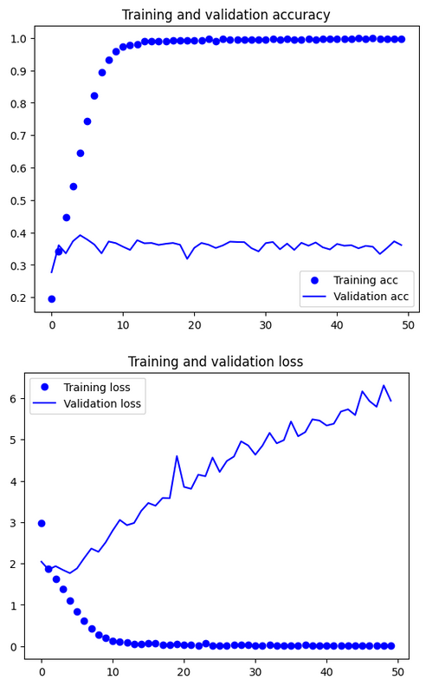

Softmax activation is a common choice for classification tasks, particularly when the categories are distinct from one another. This is because the output of the softmax function is a probability distribution across the possible categories, with each category's output falling between 0 and 1 and the sum of all outputs equaling 1. This allows the model to clearly predict the most probable category, as the output for the predicted category will be close to 1 while the outputs for the other categories will be close to 0.

On the other hand, sigmoid activation is often used for binary classification tasks, in which the categories are not mutually exclusive which makes it ineffective in multi-class classification. Either way, I still attempted to use a sigmoid activation to test its output.

For my Model 2, I added some complex layers, using a sigmoid activation function, an RMSprop learning rate of 1e-4, and increased the number of epochs to 150.

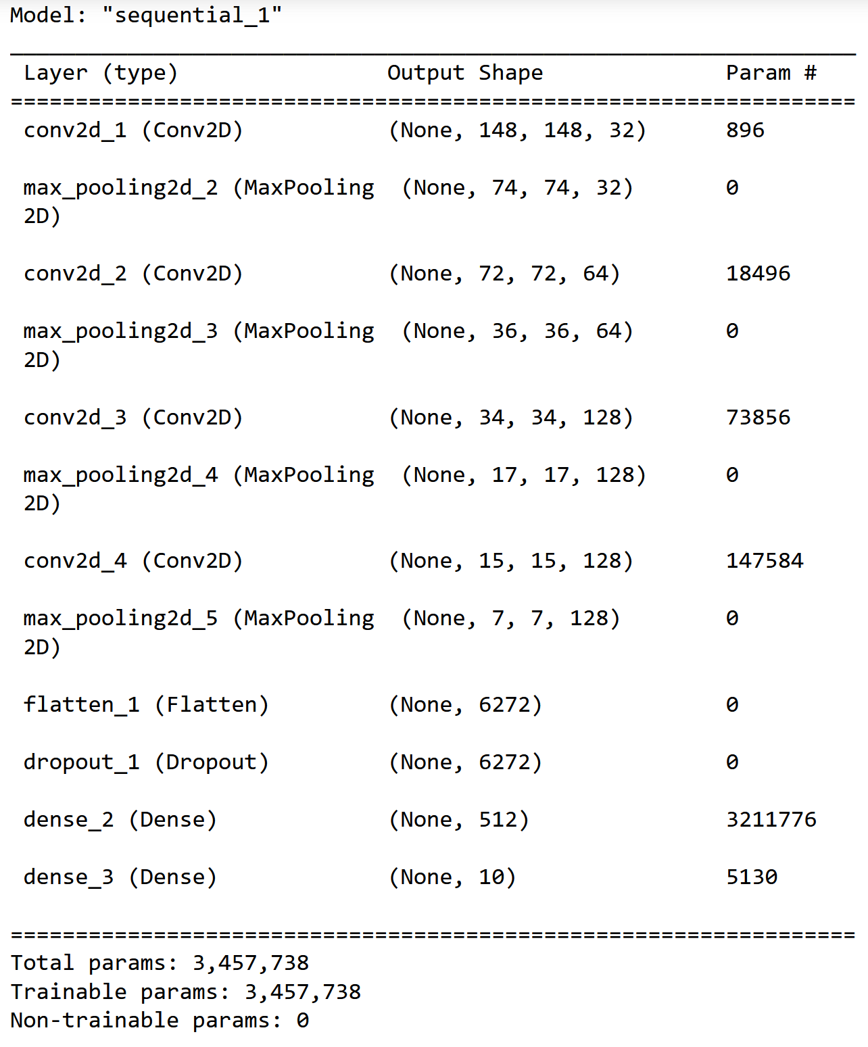

After 150 epochs, the model obtained a training accuracy of 71.59%, a validation accuracy of 66.20%, and 67.40% for testing accuracy which is a significant improvement over the baseline model. As seen from the graph below, the validation loss follows only the training loss up until epoch 40 where to begins to deviate and grow gentler, meaning that improvements begin to slow. The variance of validation loss is also extreme thus creating a fuzzy line. Although it has not started to overfit yet and can be considered to be in its optimal range, 150 epochs is already too high to consider increasing.

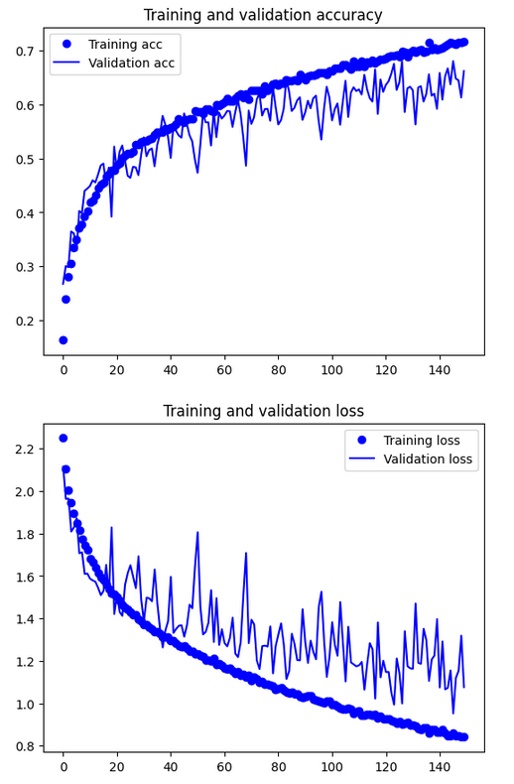

Quickly going over models 3 and 4, where different complex layers are used for testing purposes, they both did not perform all that well with not much to note for.

Model 5 shares the same layers as model 2 with two exceptions, it uses a different batch size of 20, hence the steps per epoch is 375 and validation steps is 100, and a different optimizer, the Stochastic gradient descent (SGD) optimizer.

SGD is an optimization algorithm that adjusts the model's parameters in a direction that reduces the loss function. At each iteration, SGD calculates the gradient of the loss function with respect to the model's parameters using a small batch of training data. The model's parameters are then updated in the opposite direction of the gradient, with the size of the update determined by the learning rate. This process is repeated for multiple epochs until the model reaches a minimum of the loss function.

SGD is computationally efficient because it only requires the calculation of the gradients for a small batch of data at each iteration. This makes it a good choice for large datasets that do not fit in memory. SGD is also easy to implement and can avoid local minima, which can be an issue for other optimization algorithms. However, SGD is sensitive to the choice of learning rate and may not always converge to the global minimum of the loss function. Hence, I attempted to use it for model 5.

After training completion, model 5 reached a training accuracy of 72.88%, validation accuracy of 67.40%, and testing accuracy of 66.6%, all of which are fairly similar to model 2. However, compared to model 2, the training and validation loss chart below shows that the training accuracy and loss performs better than the validation accuracy and loss up until epoch 60 where it intersects before deviating at epoch 80 as the slow grows gentler. Furthermore, the model still does not start to overfit as it only starts to enter its optimal range after 150 epochs. Compared to model 2, the variance in validation loss is also a lot less extreme. Something important to note is the difference in training accuracy and validation accuracy of model 5, there is a difference of 5%.

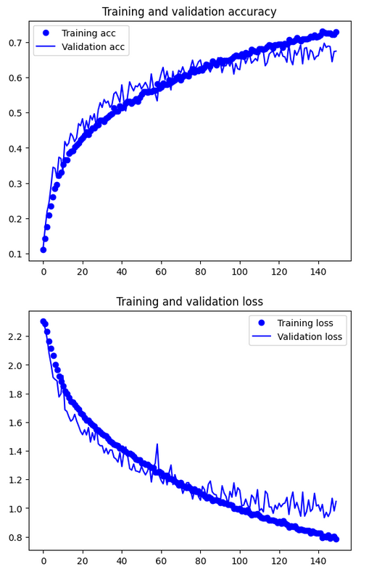

Model 6 follows only model 5 in sharing the same layers but using a softmax activation and a different batch size instead. Instead, it uses a batch size of 25.

After training the model, model 6 reached a training accuracy of 68.44% and validation of 67.95%. Although the validation accuracy of model 6 and 5 is similar, their difference between the training and validation is different. Where model 5 has a difference of 5% and model 6 has a difference of less than 1%. This shows the improvements made by the softmax activation. Looking at the charts below, the validation loss also seems to be in line with the training loss up till epoch 120 where it begins to deviate. The variance is also smaller compared to model 5 leading to smaller fuzz as it only begins to enter its optimal range, far from overfitting. With a higher epoch, the accuracy of model 6 would easily surpass model 5.

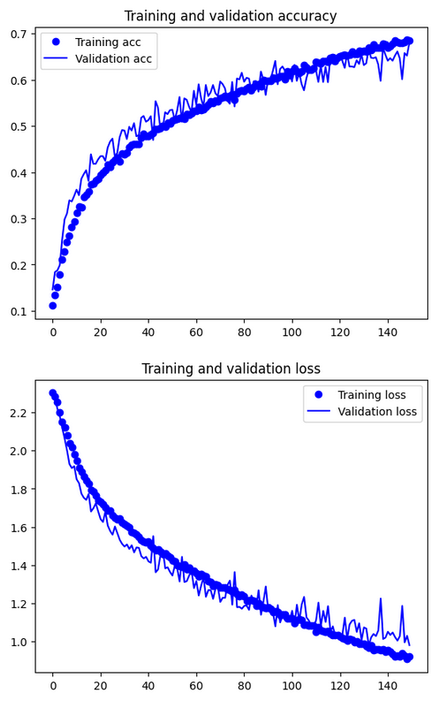

Model 7 is completely the same as model 6 except for a higher batch size of 30 instead of 25. Despite that, the model performs worse than model 6 after 150 epochs with a training accuracy of 67.07% and validation of 65.40%. One improvement from this change in batch size however, which can be seen in the chart below, is the smaller variance in validation loss causing less fuzz. Additionally, the validation accuracy and loss has barely began to deviate from the training too.

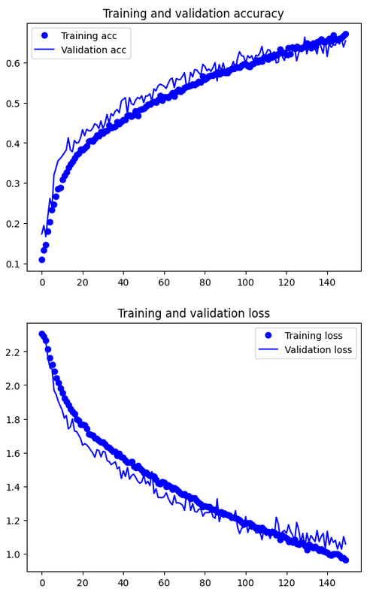

To account for this, model 8 is the exact same as model 7 but with 200 epochs instead. Despite increasing the epochs, the model has 70.29% training and 65.56% validation accuracy, which is not too different from model 7. From the chart, we can see that the validation had begun to deviate from the training and was entering its optimal range. It did not start to overfit but performance improvements was minimal.

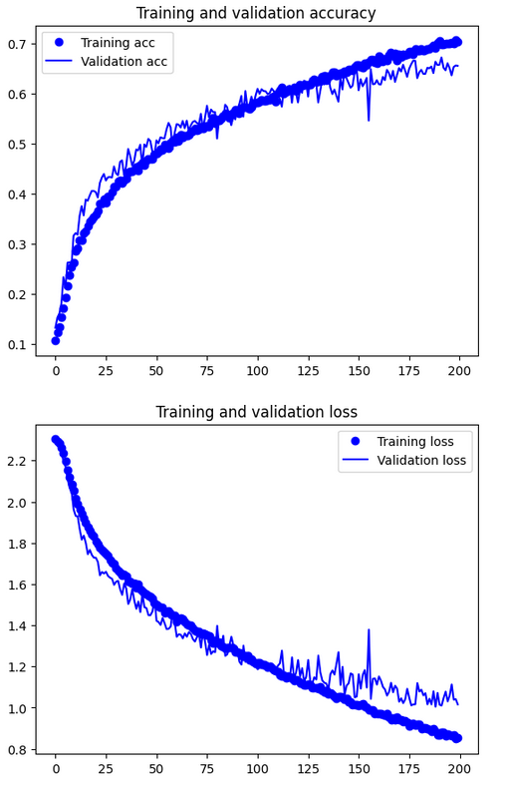

Model 9 is similar to model 7 with the exception of a different batch size and an additional dropout layer. Essentially, it performs similar to model 7 and shares a similar looking history chart. Model 10 added an additional dropout and conv2d layer as well and shares similarities to model 9 and 7. As there was no overfitting, the dropout layers barely had an effect. Model 11 adjusted the learning rate which saw an increase in training accuracy but barely in validation accuracy. However, a little overfitting did start to occur as seen below due to the increased learning rate.

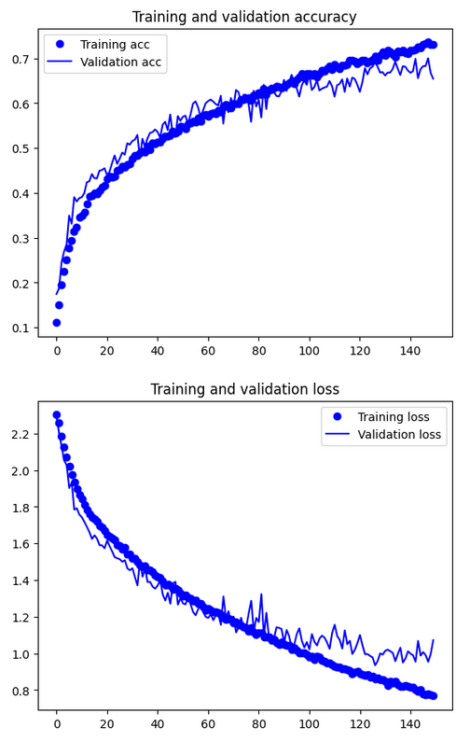

Model 12 and 13 shares the same new layers which are slightly more complex than the previous. The difference between the two models is the optimizer, with model 13 now using the Adagrad (Adaptive Gradient Algorithm) optimizer. Adagrad is a technique for optimizing machine learning models that adjusts the learning rate of each model parameter based on how often it has been updated in the past. This means that parameters that have been updated more frequently will have a lower learning rate, while those that have been updated less frequently will have a higher learning rate. Adagrad can be helpful for tasks with sparse gradients or models with many parameters, but it requires manual tuning of the initial learning rate and may converge slowly due to the monotonically decreasing learning rate. It can also be sensitive to the choice of initial learning rate and may oscillate or diverge if the learning rate is set too high.

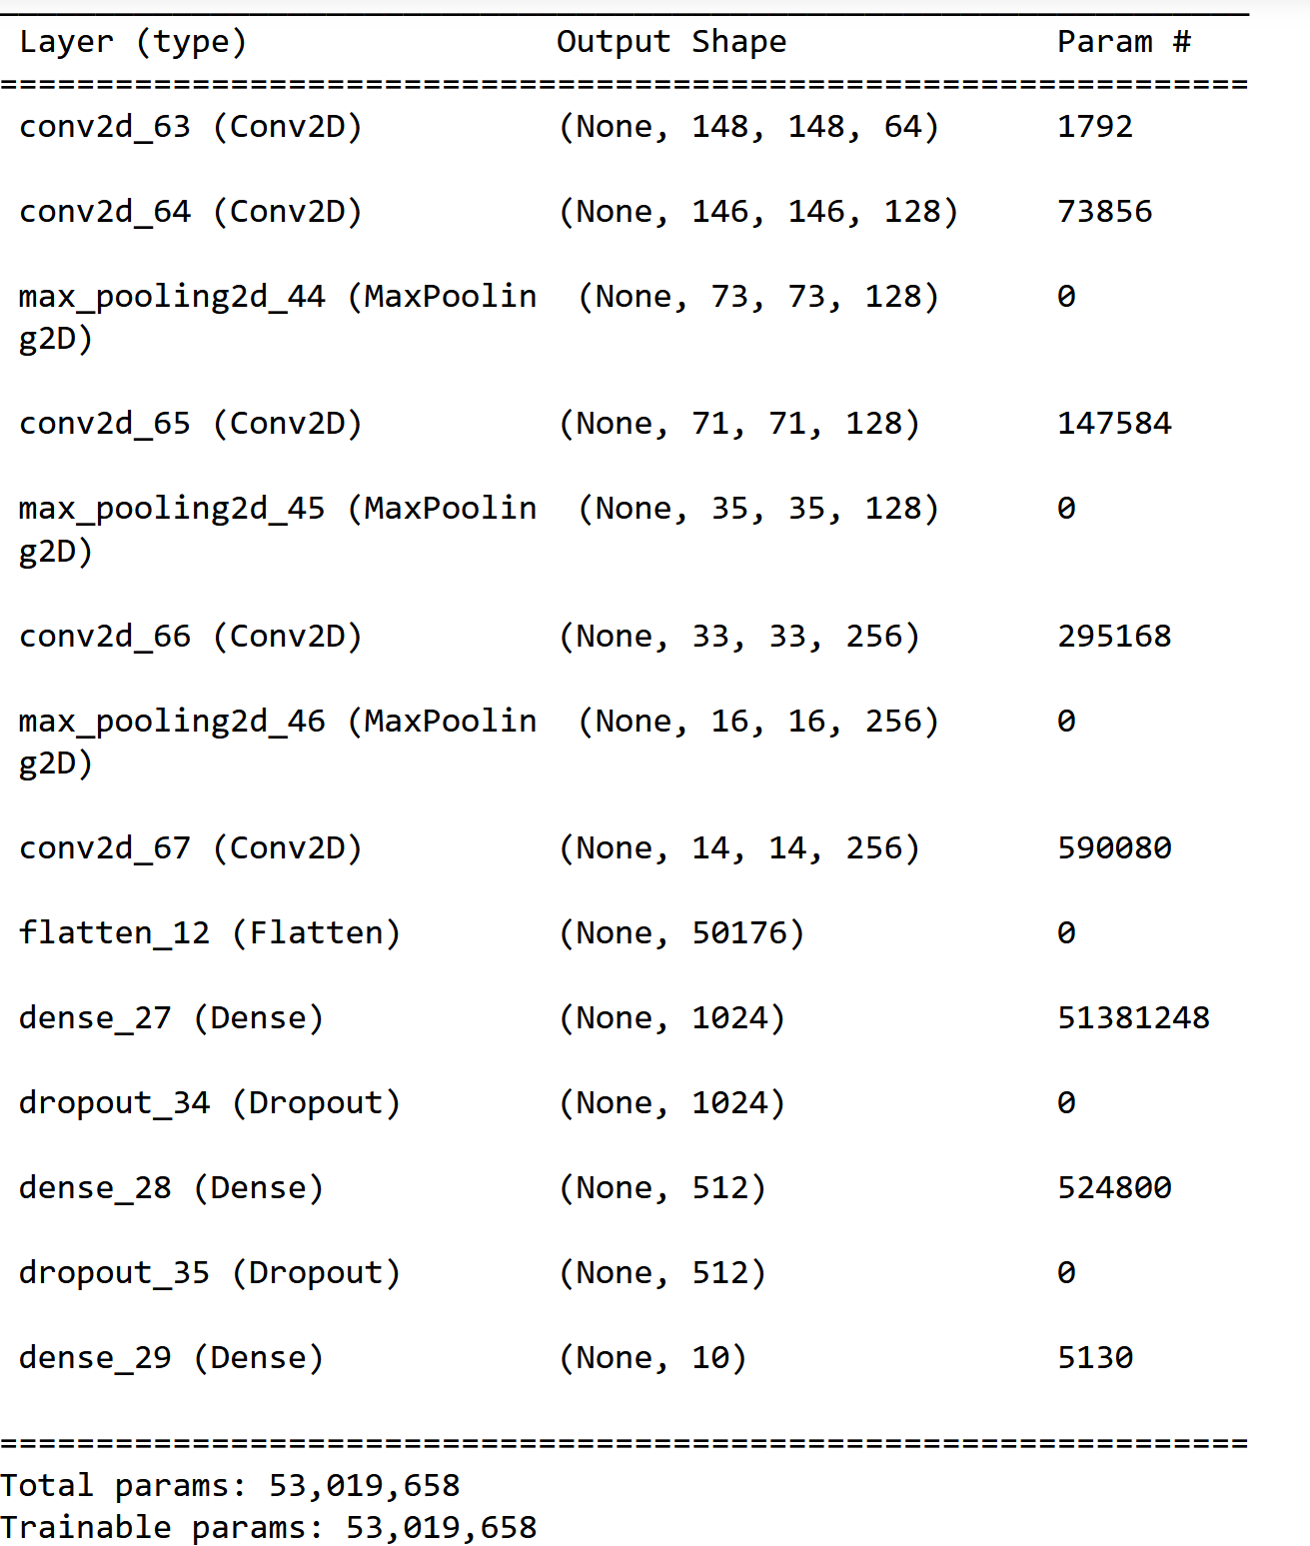

Comparing the performance and charts of the two models below. We can see that model 13 begins deviating from the training loss much earlier as well as beginning to overfit compared to model 12. Model 13 also reaches a training accuracy of 90.32% and validation of 70.90%. An additional dropout layer might be useful in stopping this dropout.

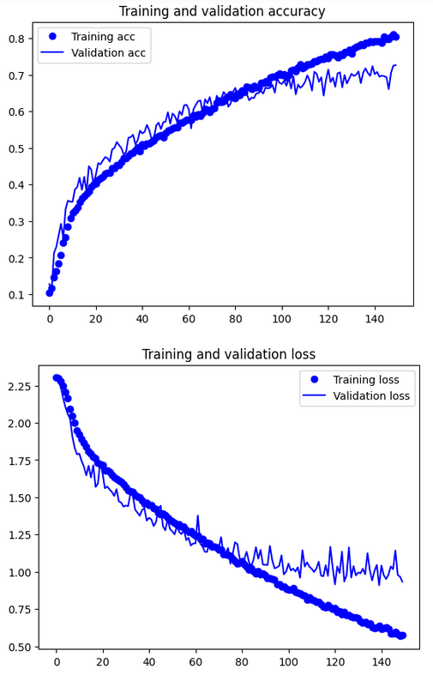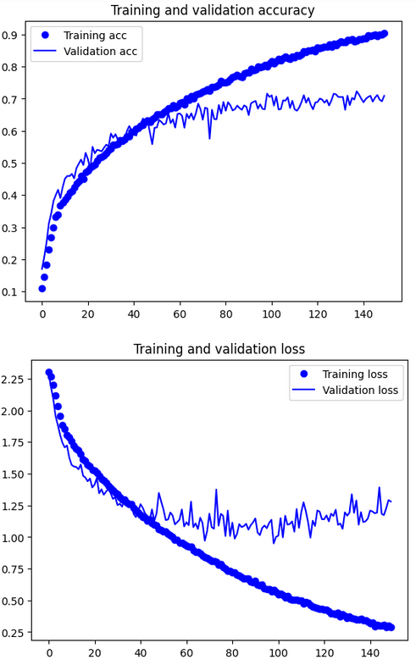

Moving onto pretrained models, model 14, 15, and 16 uses VGG16, ResNet50, and VGG19 respectively for notable performance. However, we will be talking about models 17, 18, 19, 20 and 21 which uses InceptionV3 instead.

Model 17 uses InceptionV3 with all blocks unfrozen and gives us a performance of 88.05% for training and 81.30% validation. Model 18 freezes all its blocks and gives us a baseline performance of 67.57% training and 70.10% validation giving room for fine-tuning. Model 19 freezes up to the 7th out of 9 blocks with 25 epochs and gives us 72.33% and 70.85%, still worse than the unfrozen model. Model 20 has all blocks are unfrozen and runs for 25 epochs. It has 95.33% training accuracy and 83.60% validation. Model 21, freezes up till the 7th block and has a higher learning rate of 0.015 and extends up till the 50th epoch and is able to achieve 100% training accuracy but only 67.75% validation as it began to overfit on the 3rd epoch. The difference between freezing up to the 7th and unforzen charts in model 19 and 20 can be seen below.

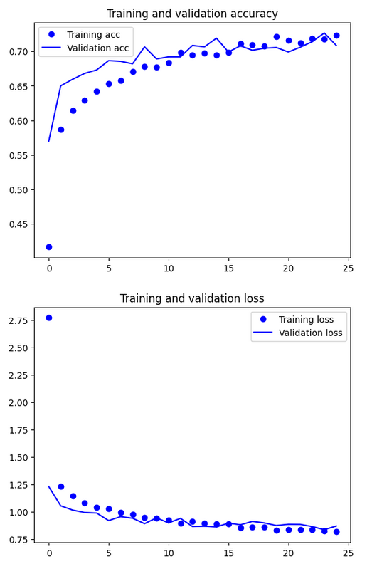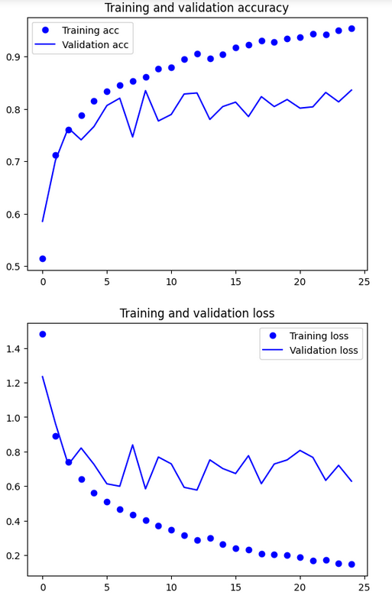

# Evaluate models using Test Images

In this section, we will evaluate the performance of the developed models using test images. We will compare the models' performance during the testing phase and recommend the best model based on this evaluation.

As I have saved most of the models that I created, totaling up to 21 different models, I am able to load in the HDF5 files of each model to check their accuracy on the test dataset, which I created in the image preprocesing section, that contains 500 images of the 10 food types. I will be using a batch size of 20, which means there will be 50 steps in the evaluation.

Firstly, a baseline model is a simple model used as a benchmark to evaluate the performance of more complicated models. It is essential to have a baseline model because it provides a reference point for comparing the performance of other models. By using a baseline model, it is possible to determine if a more complex model is actually improving the performance of the model on a given task or if the additional complexity is unnecessary and may even negatively impact the model's performance. In machine learning and data science, it is common to compare the performance of different models on a given task to determine which model is the best. By establishing a baseline model, it is possible to determine if the improvements in performance achieved by a more complex model are statistically significant or if the differences in performance are within the margin of error.

| Model | Test/Tune/Changes | Train Accuracy | Validation Accuracy | Test Accuracy |
| --- | --- | --- | --- | --- |
| 1 | Baseline Model | 99.72% | 36.10% | 34.99% |
| 2 | Added more complex layers, Sigmoid activation, Adjusted learning rate, Higher Epoch | 71.59% | 66.2% | 67.4% |
| 3 | Extremely complex layers, Softmax activation | 61.64% | 55.35% | 55.4% |
| 4 | Different layers, Using SGD optimizer | 55.39% | 52.85% | 53.2% |
| 5 | Same as model 2, Sigmoid activation, different batch size | 72.88% | 67.40% | 66.6% |
| 6 | Same as model 5, Softmax activation, different batch size | 68.44% | 67.95% | 67.80% |
| 7 | Same as model 6, different batch size | 67.07% | 65.40% | 63.4% |
| 8 | Same as model 7, 200 epoch | 70.29% | 65.56 | 67.20% |
| 9 | Same as model 7, added dropout, different batch size | 66.53% | 66.95% | 66% |
| 10 | Same as model 9, added dropout and conv2d layers | 68.11% | 65.45% | 66.40% |
| 11 | Same as model 7, different learning rate | 73.04% | 65.45% | 64.00% |
| 12 | Different layers, SGD optimizer | 80.51% | 72.60% | 72.80% |
| 13 | Same as model 12, AdaGrad optimizer | 90.32% | 70.90% | 72.2% |
| 14 | Pretrained Model, VGG16, sigmoid activation, RMSprop optimizer | 85.19% | 79.35% | 78.00% |
| 15 | ResNet50, sigmoid activation | 86.32% | 78.65% | 77.80% |
| 16 | VGG19, softmax activation, SGD optimizer | 69.08% | 73.75% | 74.60% |
| 17 | InceptionV3, softmax activation, 512 dense layer, AdaGrad optimizer | 88.05% | 81.30% | 78.80% |
| 18 | Same as model 17, freeze all blocks | 67.57% | 70.10% | 70.40% |
| 19 | Same as model 17, freeze up to block 7, 25 epoch | 72.33% | 70.85% | 70.00% |
| 20 | Same as model 17, 25 epoch | 95.33% | 83.60% | 84.2% |
| 21 | Same as model 19, 50 epoch | 100% | 67.75% | 66.80% |

Looking at the table created from earlier, the best model created from scratch is model 12 with a testing accuracy of 72.80%. As for pretrained the best model is model 20 with an accuracy of 84.2% making it the best model overall.

# Use the Best Model to perform classification

In this section, we will use the best model identified in the previous steps to make predictions on 11 food images.

The purpose of this step is to test the ability of the best model to accurately classify new, previously unseen images of food. This will provide further insight into the generalizability and effectiveness of the model.

The code given along with the assignment jupyter notebook begins by loading a list of food items from a text file ('20.txt') and storing it in the 'food_list' variable. Two functions are then defined, the first function, 'image_process()', takes an image file as input and processes it for use in the model. Specifically, it loads the image using 'load_img', resizes it to a specified size ('img_size'), converts it to an array using 'img_to_array', and normalizes the pixel values by dividing by 255. The second function, 'prediction()', takes a model, an image array, and a list of food items as input and returns the predicted class and a probability distribution over the classes. The function first uses the model to make a prediction on the image array, which returns an array of probabilities for each class. It then creates a Pandas dataframe with the columns equal to the list of food items and the rows equal to the probability distribution. The function returns the dataframe and the predicted class, which is determined by finding the class with the highest probability.

It then loads and displays an image i.e. ('grilledsalmon.jpg') using 'imshow' and 'imread'. The image is then processed using the 'image_process()' function and the result is stored in 'img_array'. It then makes a prediction on the image using the 'prediction()' function and stores the result in the variables 'prob_df' and 'result'. The predicted class and the probability distribution dataframe are then printed.

The image of the food along with the prediction accuracy is as seen below. A thing to note is that I used two different pizza images. One can be considered less obvious as it technically counts as two pictures of pizza with people holding them at once and the other is clearly a pizza. This is done as I wanted to test the capabilities of the model. Surprisingly, it was able to predict that the less obvious pizza image was a pizza with a probability of 30%.

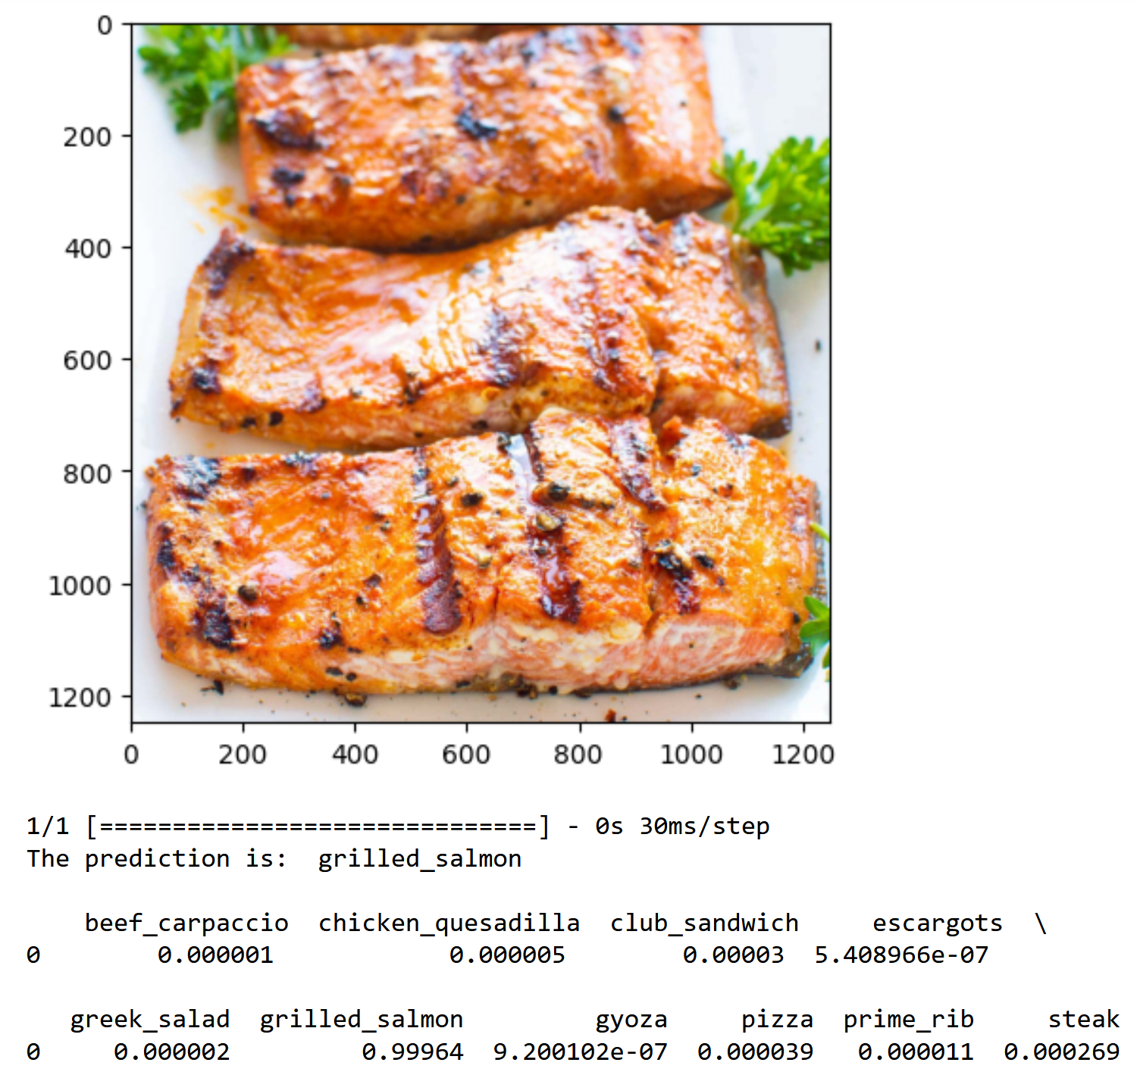

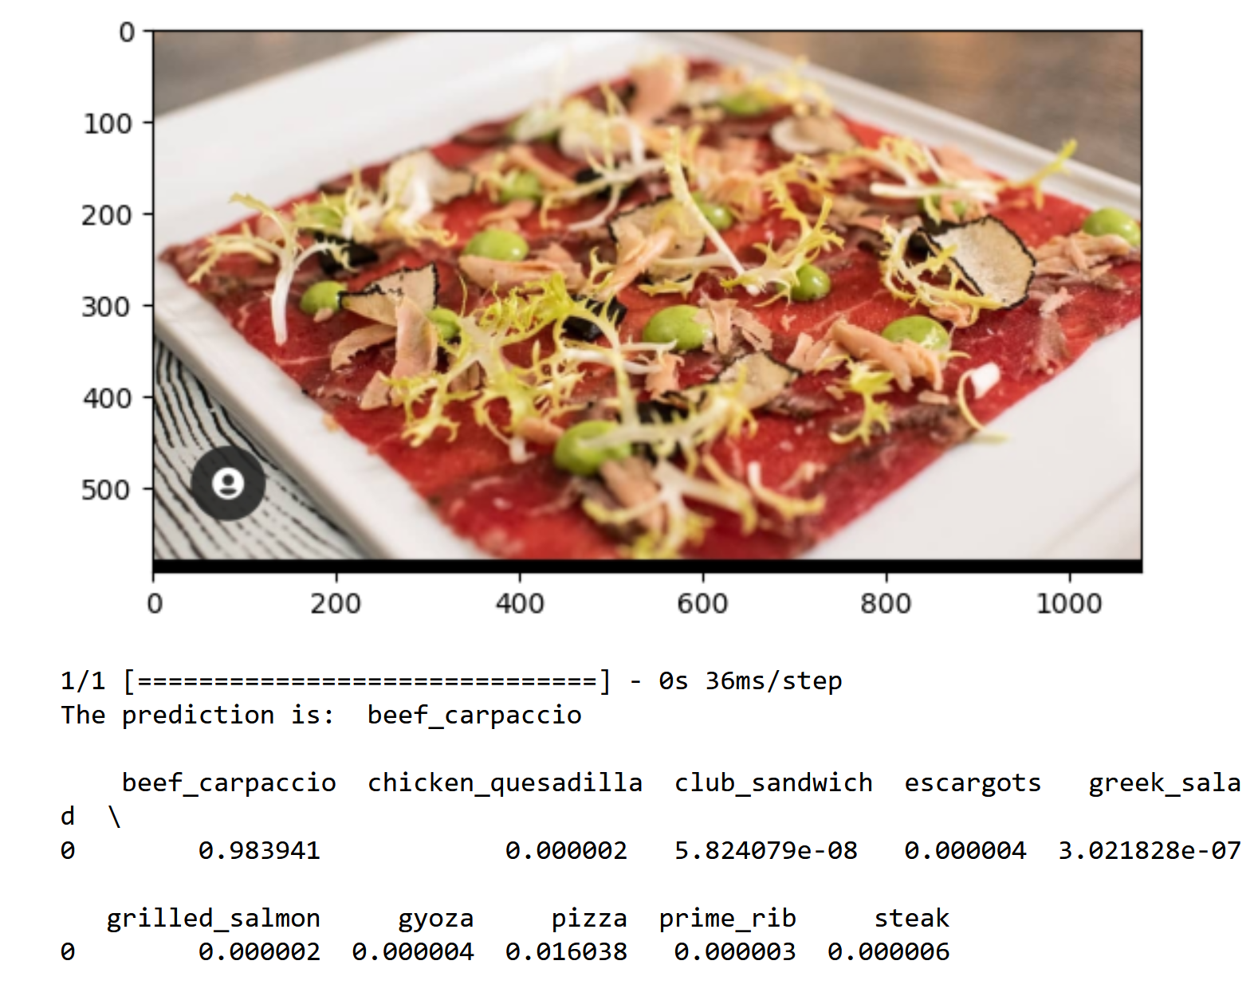

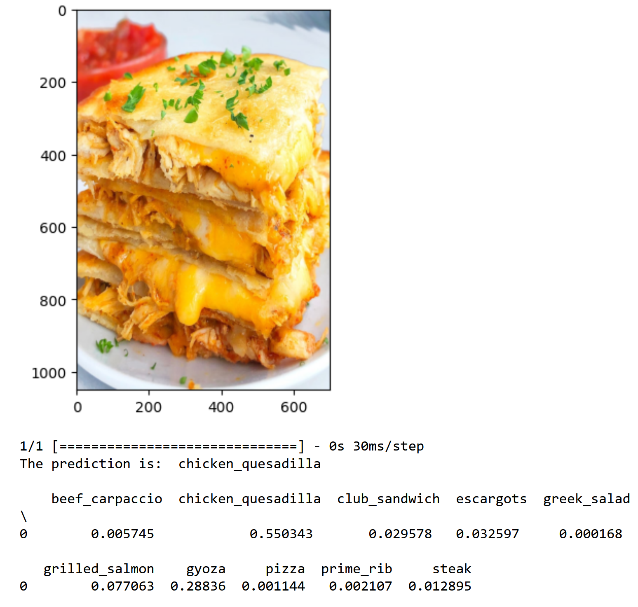

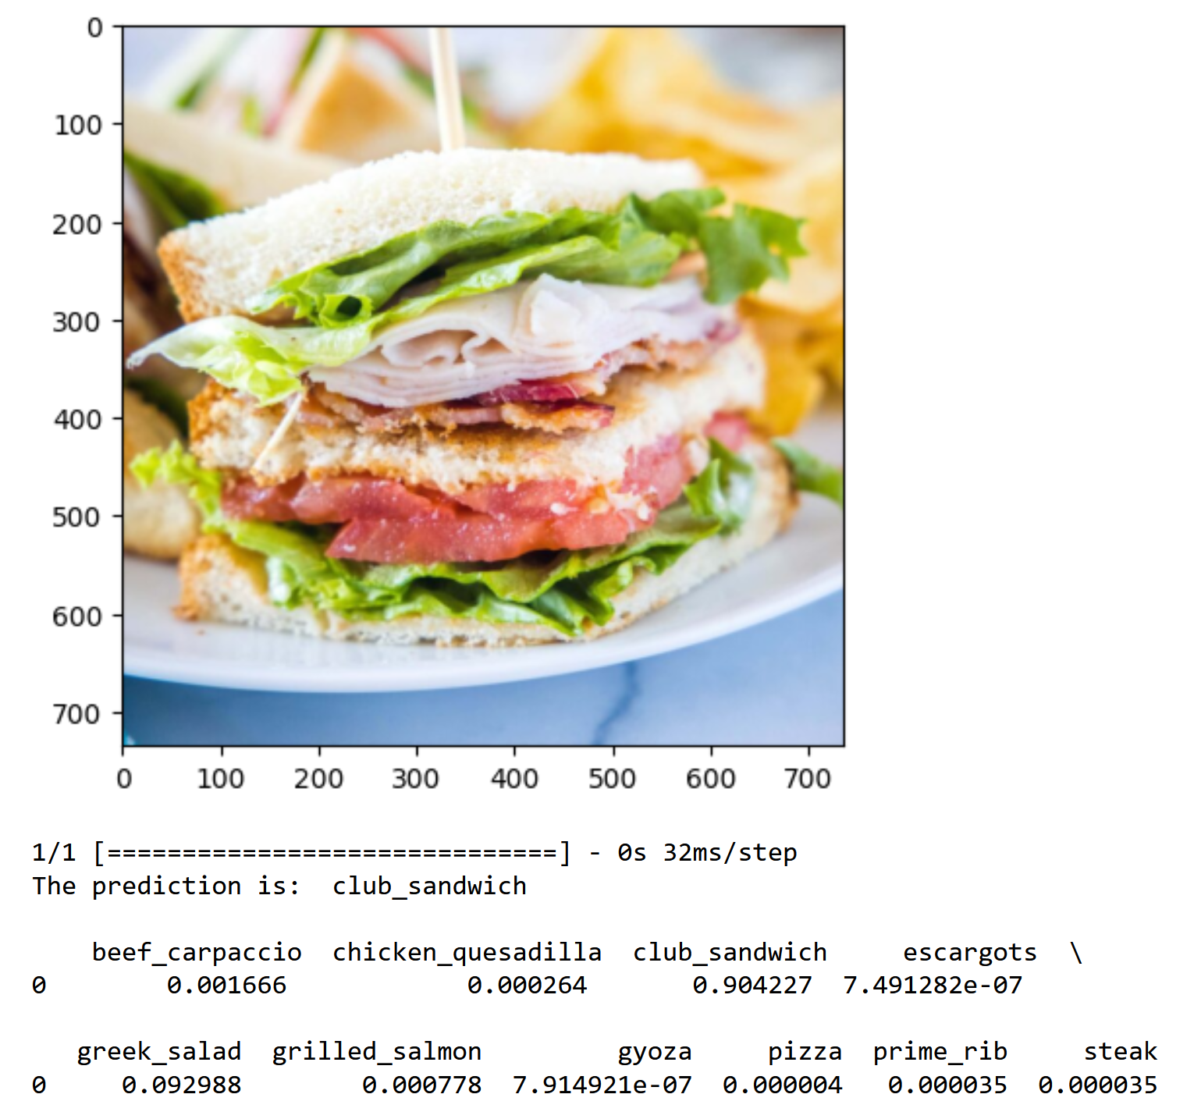

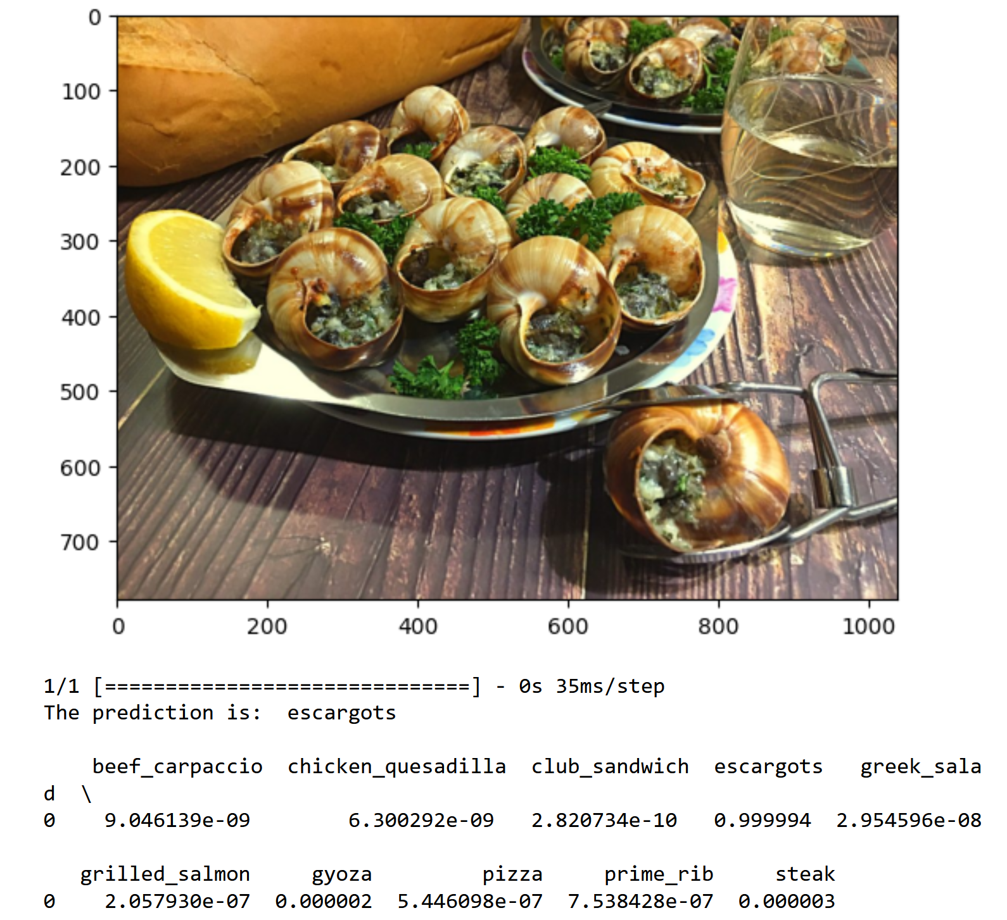

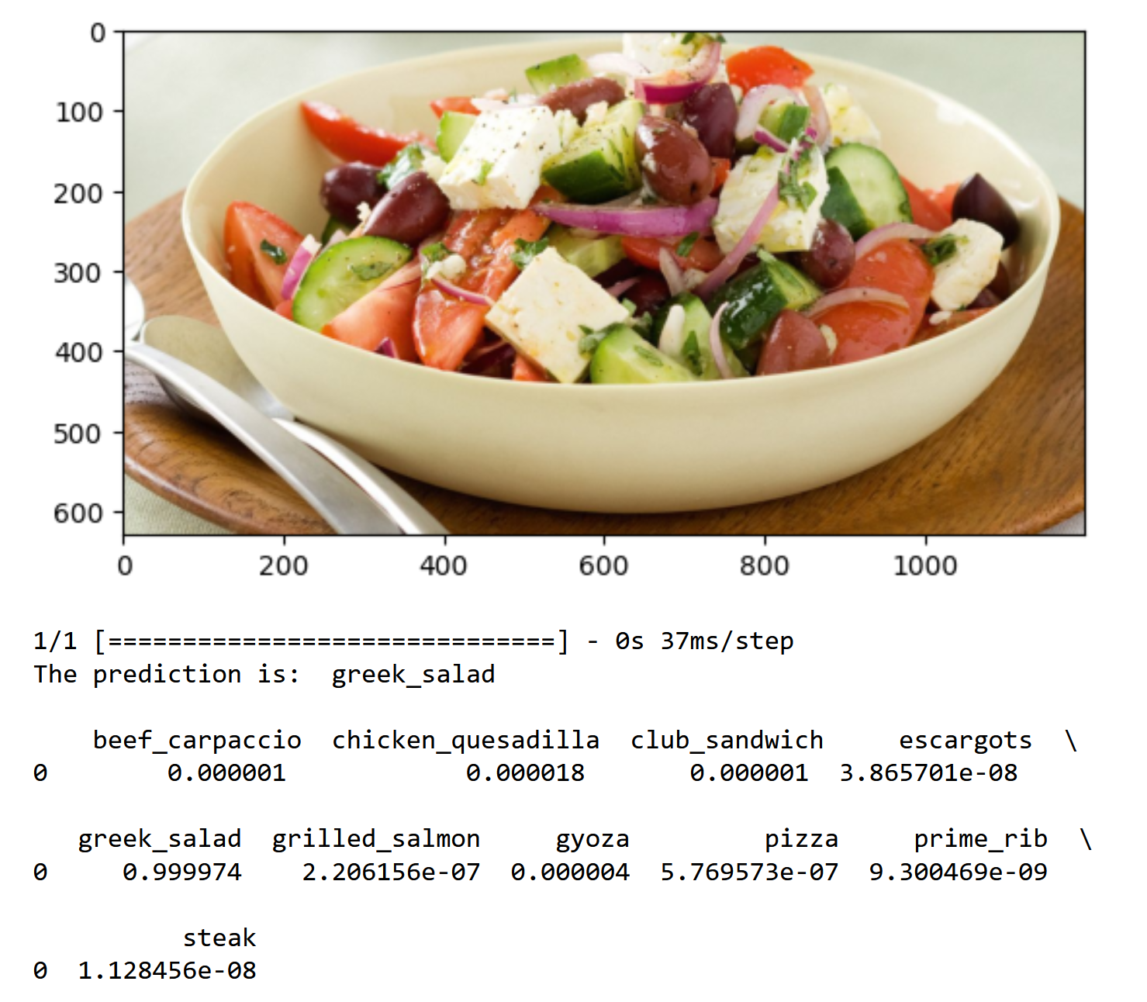

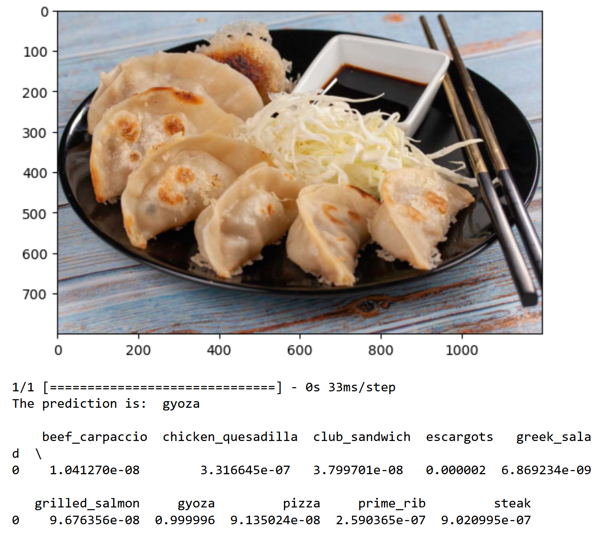

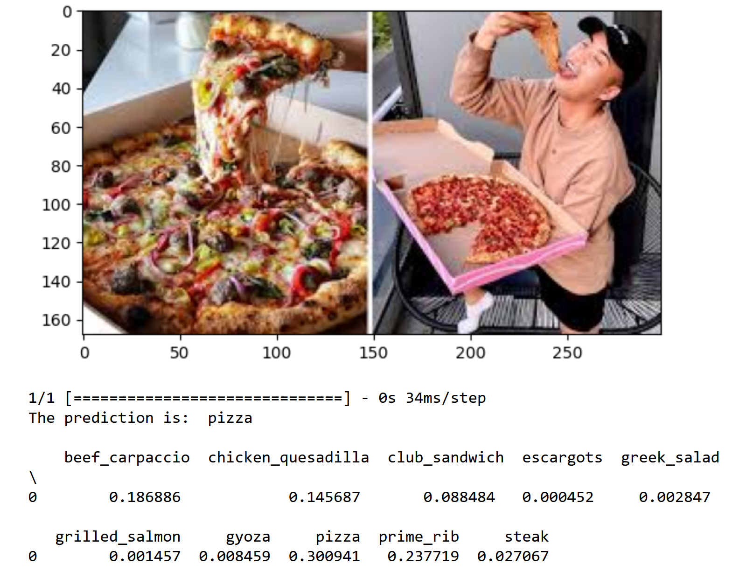

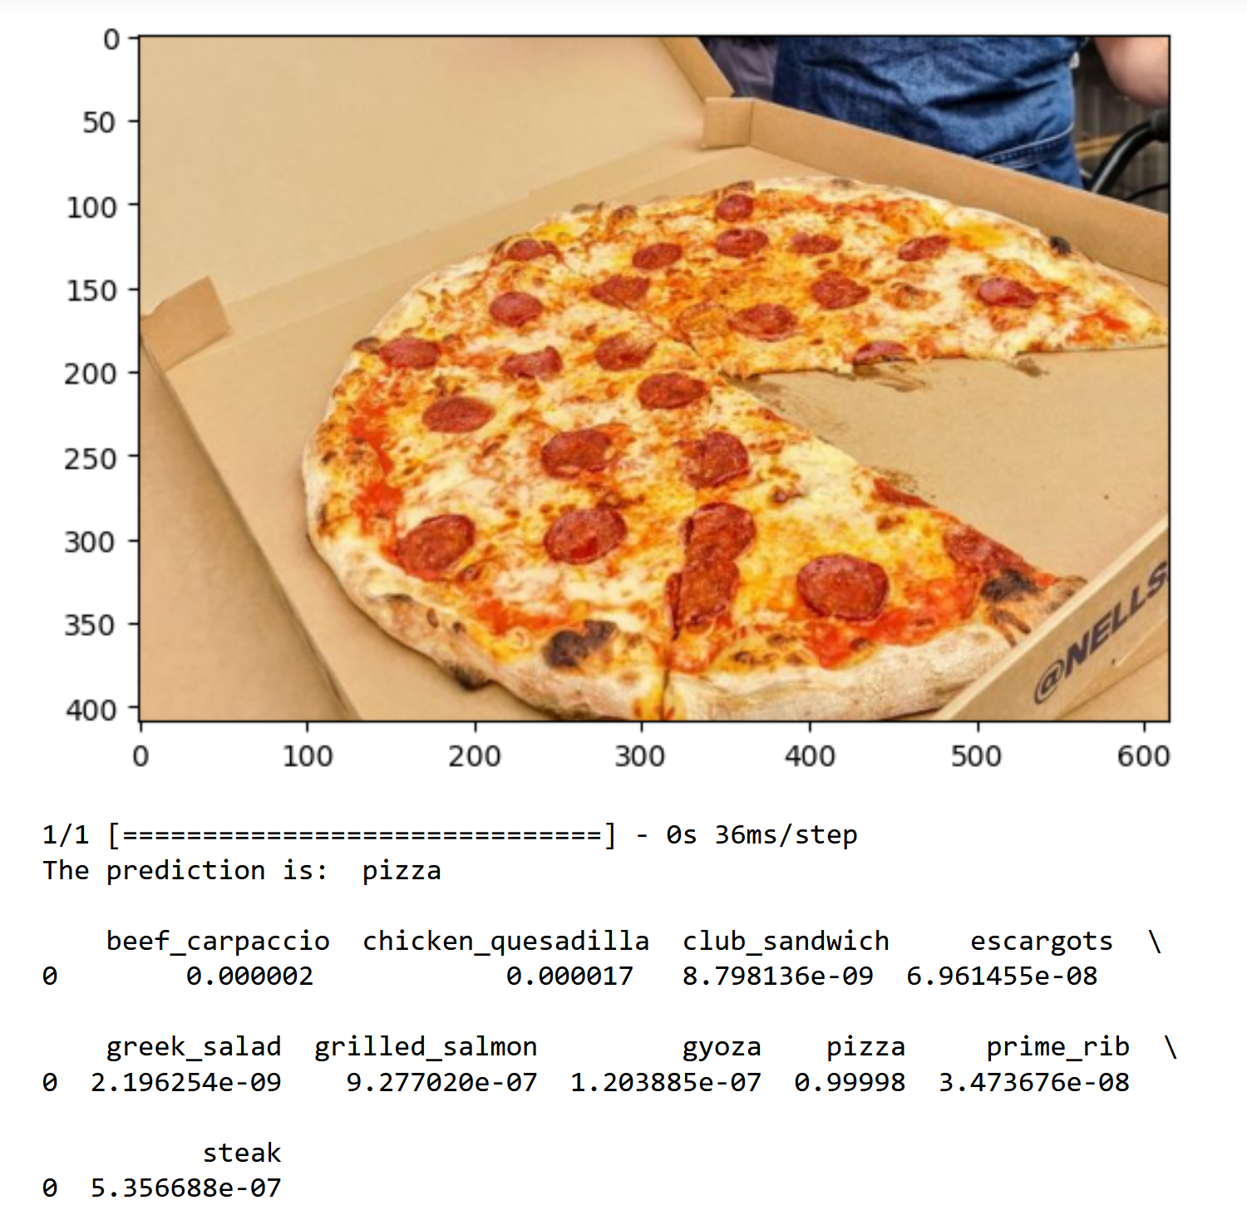

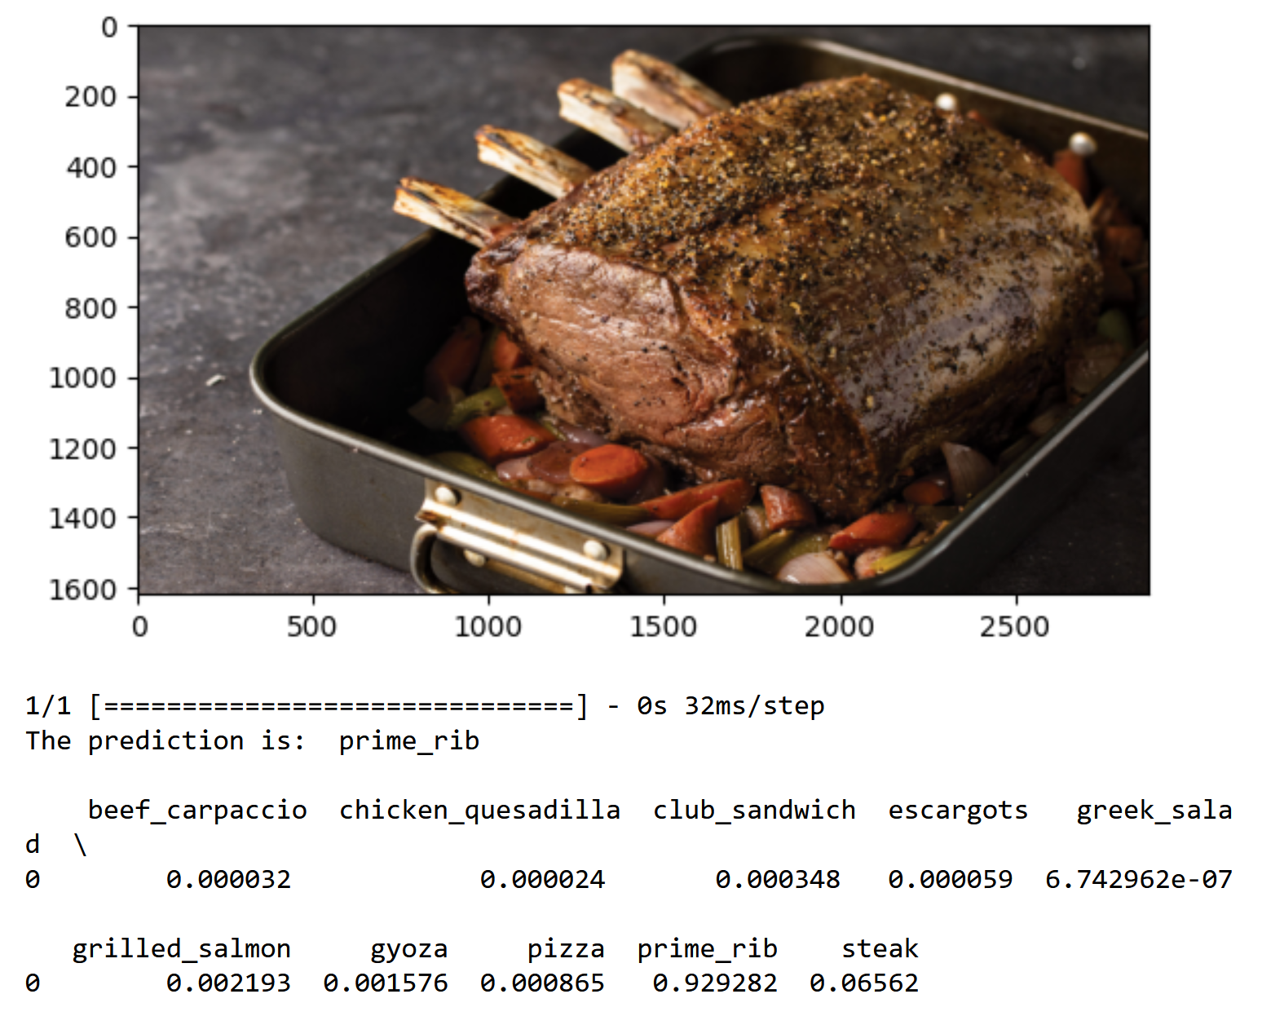

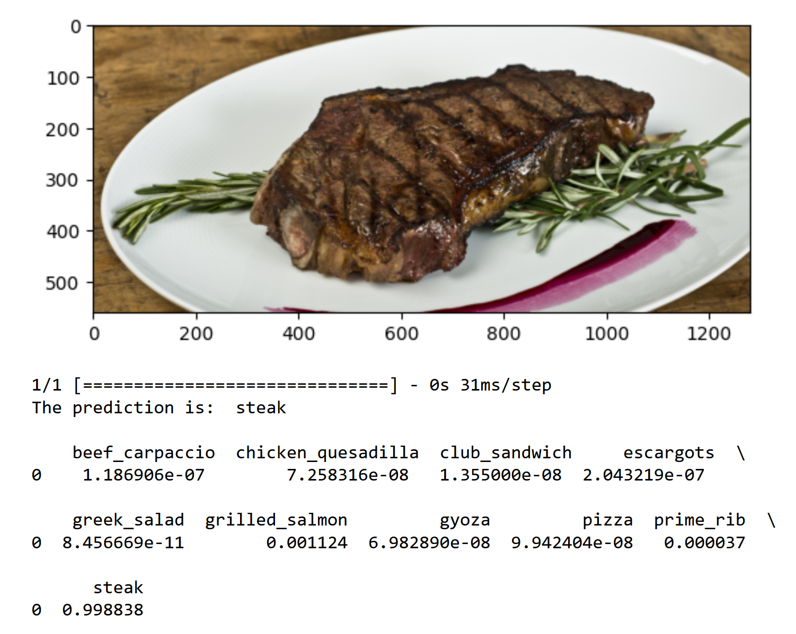

# Summary

The aim of this assignment was to build and train image classification models to recognize and classify 10 different types of food. The dataset used for this project was a collection of 101,000 images of food organized by type, which was downloaded from Kaggle. The goal was to develop at least two different models for this classification task, one trained from scratch using conv2D and dense layers, and another utilizing pre-trained models. The models were evaluated using the test images, and the best model was recommended based on performance and fine-tuned. The best model was then used to classify additional food images downloaded from the internet. In total, 21 models were developed and trained, with the final model achieving a test accuracy of 84.2%. The model with the highest validation accuracy was model 20, which was a pretained model utilizing InceptionV3. This model was chosen as the best model for the task to predict 11 images picked up from the internet.

Some potential improvements can be increasing the number of epochs or changing the hyperparameters of each model until overfitting occurs as there were very few overfitting occurrences in this assignment. When a model overfits, it means that the model has already surpassed its optimal range and can be further optimized through changing hyperparameters. Due to only several overfitting occurrences, it feels as though the accuracy of the model has yet to be truly optimized.

| Model | Test/Tune/Changes | Train Accuracy | Validation Accuracy | Test Accuracy |
| --- | --- | --- | --- | --- |
| 1 | Baseline Model | 99.72% | 36.10% | 34.99% |
| 2 | Added more complex layers, Sigmoid activation, Adjusted learning rate, Higher Epoch | 71.59% | 66.2% | 67.4% |
| 3 | Extremely complex layers, Softmax activation | 61.64% | 55.35% | 55.4% |
| 4 | Different layers, Using SGD optimizer | 55.39% | 52.85% | 53.2% |
| 5 | Same as model 2, Sigmoid activation, different batch size | 72.88% | 67.40% | 66.6% |
| 6 | Same as model 5, Softmax activation, different batch size | 68.44% | 67.95% | 67.80% |
| 7 | Same as model 6, different batch size | 67.07% | 65.40% | 63.4% |
| 8 | Same as model 7, 200 epoch | 70.29% | 65.56 | 67.20% |
| 9 | Same as model 7, added dropout, different batch size | 66.53% | 66.95% | 66% |
| 10 | Same as model 9, added dropout and conv2d layers | 68.11% | 65.45% | 66.40% |
| 11 | Same as model 7, different learning rate | 73.04% | 65.45% | 64.00% |
| 12 | Different layers, SGD optimizer | 80.51% | 72.60% | 72.80% |
| 13 | Same as model 12, AdaGrad optimizer | 90.32% | 70.90% | 72.2% |
| 14 | Pretrained Model, VGG16, sigmoid activation, RMSprop optimizer | 85.19% | 79.35% | 78.00% |
| 15 | ResNet50, sigmoid activation | 86.32% | 78.65% | 77.80% |
| 16 | VGG19, softmax activation, SGD optimizer | 69.08% | 73.75% | 74.60% |
| 17 | InceptionV3, softmax activation, 512 dense layer, AdaGrad optimizer | 88.05% | 81.30% | 78.80% |
| 18 | Same as model 17, freeze all blocks | 67.57% | 70.10% | 70.40% |
| 19 | Same as model 17, freeze up to block 7, 25 epoch | 72.33% | 70.85% | 70.00% |
| 20 | Same as model 17, 25 epoch | 95.33% | 83.60% | 84.2% |
| 21 | Same as model 19, 50 epoch | 100% | 67.75% | 66.80% |